Author: Fenner Holman

PUBLICATION DATE: Feb 2022

License

**Dual Camera Image Processing Software**

User Manual

Version 1.1

Table of Contents

Contents

**Chapter 1. Overview** 2

**1.1 How it works** 2

**Chapter 2. Installation and Activation** 3

**Chapter 3. Image Calibration Tool** 4

**3.1 The Tool** 4

**3.2 The Workflow** 5

**3.3 Batch Processing** 5

**3.3.1 Bath Processing Workflow** 6

**3.4 Errors** 6

**Chapter 4. Ortho Merger Tool** 7

**4.1 The Tool** 7

**4.2 The Workflow** 8

**4.3 Errors** 8

**Chapter 5. Shapefile Generator** 9

**5.1 The Tool** 9

**5.2 The Workflow:** 9

**5.3** **Errors** 10

**Chapter 6. Data Extractor Tool** 11

**6.1 The Tool** 11

**6.2 The Workflow** 12

**6.3 Errors** 12

**Notes** 13

# **Chapter 1. Overview**

This **UAV Data Tool Software Package** has been developed to provide several different tools to aid and automate the processing, analysis and extraction of data. Primarily these tools are designed use with UAV data collected for phenotyping of field-based crop trials; however, several tools can be used more widely on a range of different datasets.

This manual provides a brief overview of the included tools including what they do and how to use them.

All tools have been developed in collaboration between King’s College London and Rothamsted Research.

## **1.1 How it works**

Within the software package, there are 4 separate tools; these are:

1. **Image Calibration Tool**

This tool is used to calibrate imagery collected vis the custom-made Dual Sony α6000 camera multispectral system, used by Rothamsted Research.

* 1. Conversion of images from RAW to TIF format.
  2. Correction of vignetting within individual images.
  3. Normalisation of exposure settings – ISO, Aperture, Shutter Speed.
  4. Correction for total solar irradiance at time of image capture.

**NOTE**: This tool is highly specialised and use with imagery captured from any other camera is not advised.

1. **Ortho Merger**

This tool merges orthomosaics from separate sensors into a single file for improved storage and handling. Additional features include calculation of NDVI is NIR and Red bands are provided, and normalisation of 3D models if both DEM and DSM are provided.

1. **Shapefile Generator**

The Shapefile Generator Tool is used to convert any shapefile defining target Areas Of Interest (AOI) into a single geoJSON file. Use of a geoJSON file improves efficiency of storage and analysis.

1. **Data Extractor**

The data extractor tool is used to statistically sample any spatial orthomosaic or raster file; utilising a geoJSON to define the target AOIs.

# **Chapter 2. Installation and Activation**

The UAV Data Tool Software package comes as a self-contained executable file (.exe), meaning no installation of required packages or software is required. To launch the tool, double click the executable file, the software tool will load, and the main window will be displayed as below, the tool is ready to use.

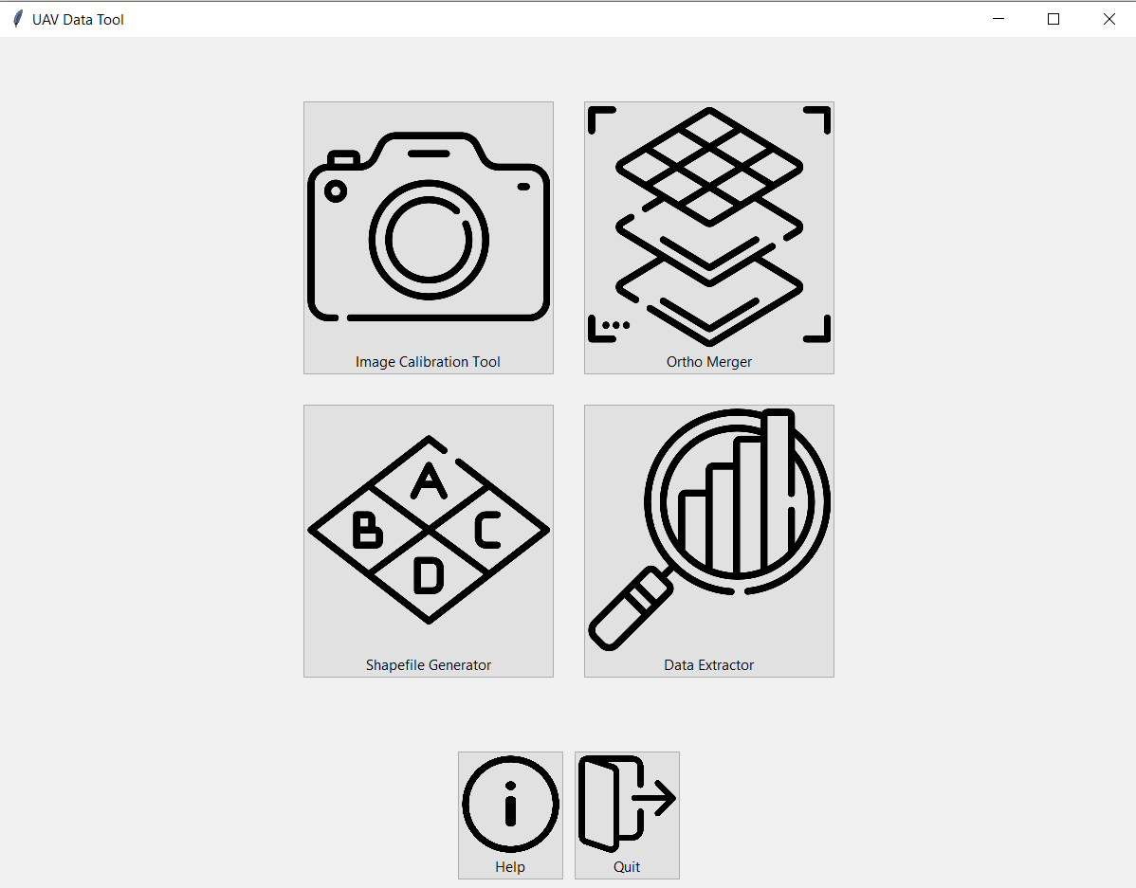

1

2

3

4

5

6

1. Image Calibration Tool
2. Ortho Merger
3. Shapefile Generator
4. Data Extractor
5. Help – pop-up help window with more information.
6. Quit – end all processing and exit software.

# **Chapter 3. Image Calibration Tool**

This chapter will provide a walk-through of the process of calibrating RAW imagery into TIFF reflectance images ready for processing with any structure from motion photogrammetry software e.g. Agisoft Photoscan/Metashape.

## **3.1 The Tool**

To access the tool, from the homepage select the Image Calibration Tool button. This will open the tool and present the page below.

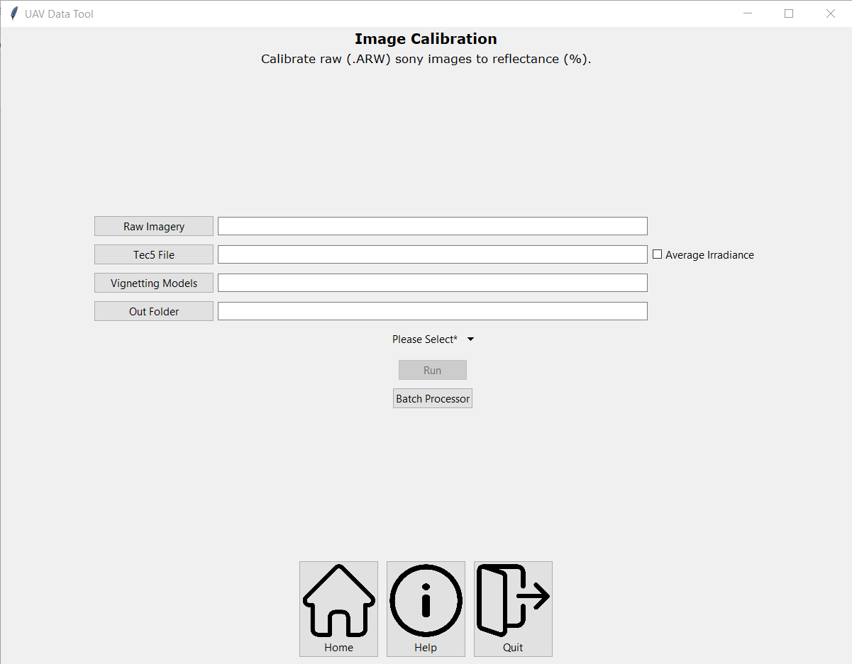

2

1

3

4

6

5

8

7

1. **Raw Imagery** – the folder containing the raw imagery for a single camera and flight, in the Sony proprietary raw file format *.ARW. This folder should be named either **RGB** or **NIR** to indicate which camera the images are from
2. **Raw Tec5 File** – the excel spreadsheet containing the raw Tec5 data collected during the flight. This file needs to contain readings from both the upwelling and downwelling sensors for each time stamp. **This file must be named /Tec5_ddmmyy.xlsx**
3. **Vignetting Folder** – the location and folder where the vignetting filters generated should be saved.
4. **Output folder** – the location and folder where the final processed imagery should be saved
5. **Average Irradiance** – if box is ticked this will produce a single averaged Tec5 irradiance correction for the entire image dataset, rather then matching by timestamp. This can be used when issues such as poor clock alignment means direct matching of timestamp is not possible.
6. **Camera** – select which camera was used to collect the imagery being processed, either RGB or NIR.
7. **Run** – Run the tool
8. **Bath Processor** – Opens the batch processing

**NB.** The software is designed to auto-fill inputs based on the Raw folder selected. Please check all inputs are correct before running the software.

## **3.2 The Workflow**

1. Fill in required folder, file, or input for numbers 1-6.
2. After double checking inputs, click run (7).
3. Monitor progress bar and CMD window for progress and in case of errors.

## **3.3 Batch Processing**

To allow for greater processing efficiency of multiple datasets, it is possible to batch multiple datasets together and process them in a single workflow. The workflow for processing in batches is outlined below.

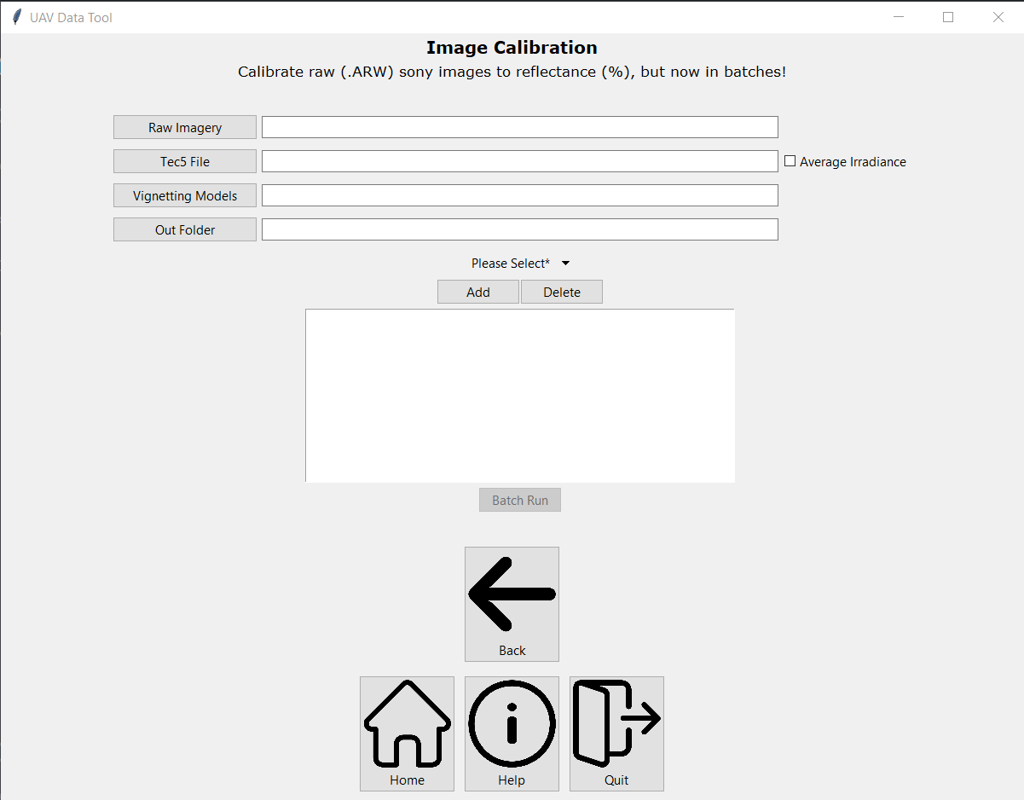

1

2

3

4

5

6

7

8

9

1. **Raw Imagery** – the folder containing the raw imagery for a single camera and flight, in the Sony proprietary raw file format *.ARW. This folder should be named either **RGB** or **NIR** to indicate which camera the images are from
2. **Raw Tec5 File** – the excel spreadsheet containing the raw Tec5 data collected during the flight. This file needs to contain readings from both the upwelling and downwelling sensors for each time stamp. **This file must be named /Tec5_ddmmyy.xlsx**
3. **Vignetting Folder** – the location and folder where the vignetting filters generated should be saved.
4. **Output folder** – the location and folder where the final processed imagery should be saved
5. **Average Irradiance** – if box is ticked this will produce a single averaged Tec5 irradiance correction for the entire image dataset, rather than matching by timestamp. This can be used when issues such as poor clock alignment means direct matching of timestamp is not possible.
6. **Camera** – select which camera was used to collect the imagery being processed, either RGB or NIR.
7. **Add/Delete** – Add or Delete dataset from bath processing queue.
8. **Bath Processor Window** – Displays all datasets in the queue for processing.
9. **Batch Run** – Run the tool on each dataset added to bath queue.

## **3.3.1 Bath Processing Workflow**

1. Fill in required folder, file, or input for numbers 1-6.
2. After double checking inputs, click Add (7) to add set to batch queue.
3. Continue to add to batch queue as needed; click Delete (7) to remove set.
4. After double checking inputs, click run (8).
5. Monitor progress bar and CMD window for progress and in case of errors.

## **3.4 Errors**

1. If the inputs do not autofill, ensure that the folder being added is named either **RGB** or **NIR.**
2. If a specific input does not auto-complete, please ensure it exists and is contained in the same location as the raw imagery folder.
3. If the tool finishes without producing final images, check the CMD prompt window for errors.

# **Chapter 4. Ortho Merger Tool**

The Ortho Merger tool is designed to stack georeferenced Orthomosaics, or other spatial datasets from multiple imaging sources (e.g., visible, DEM, thermal) into a single multiband image file. Its primary focus is to merge data collected using Rothamsted’s Sony based Dual COTS camera VIS/NIR system into a single file for better storage and analysis.

Key features:

* Calculation of NDVI if both Red and NIR bands are included.
* If both DEM (bare ground) and DSM are provided, the output DSM will be normalised.
* Will request and integrate band names into final output if not in input files.
* Can be used to add new layers to existing multilayer (merged) files.
* All layers maintain original spatial resolution and are projected to WGS84.

## **4.1 The Tool**

To access the tool, from the homepage select the Ortho Merger button. This will open the tool and present the page below.

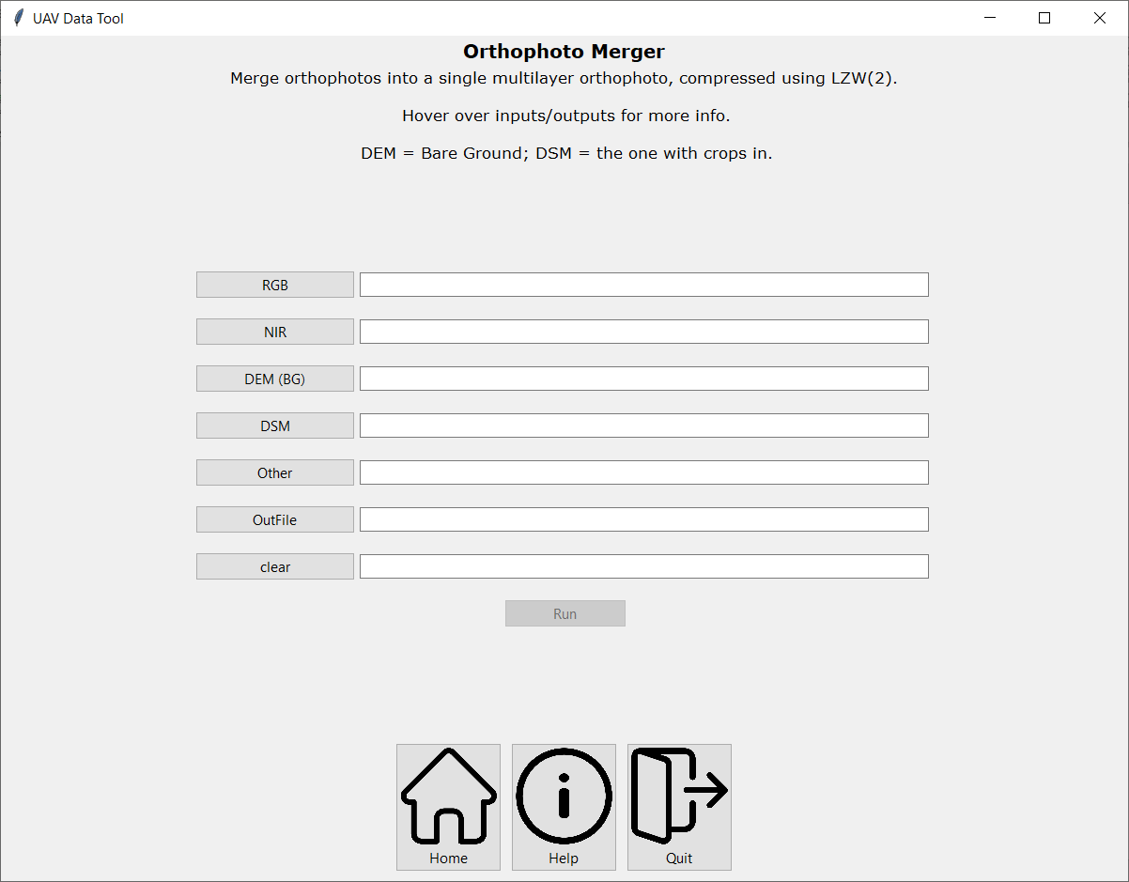

1

3

2

4

5

6

8

7

The tool takes several inputs which are explained below:

1. **RGB** – The georeferenced RGB orthomosaic generated from the Sony cameras or other VIS/RGB sensor. **NB:** This input is also used for adding new layers to existing merged files, it will request band names if not present
2. **NIR** – The georeferenced NIR orthomosaic generated from the Sony NIR camera or other NIR sensor.
3. **DEM (BG)** – The georeferenced Bare Ground (BG) Digital Elevation Model (DEM) orthomosaic generated from Photogrammetry software e.g., Agisoft Metashapes.
4. **DSM** – The georeferenced Digital Surface Model (DEM) orthomosaic generated from Photogrammetry software e.g., Agisoft Metashapes. **NB:** If DEM(BG) and DSM are provided, normalised DSM will be outputted.
5. **Other** – Any other georeferenced spatial dataset to be included e.g., Thermal ortho. Band name will be requested when using this option.
6. **Out File** – Location and file name where the output is to be saved.
7. **Clear** – This entry presents to the band names set for the RGB input ortho. These can be edited in the entry box or deleted if need be.
8. **Run** – Run the Ortho Merger Tool.

**NB.** The tool does not require all orthomosaics to work, it will work with two or more.

## **4.2 The Workflow**

To steps below describe the steps taken to process a single dataset:

1. Select all input datasets to be included in the merged final output. A file must be provided to the RGB input.
2. 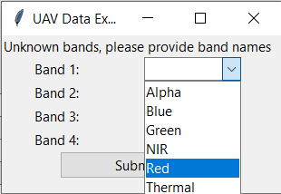Provide band names for the primary (RGB) dataset as per image below:
3. Repeat for each dataset that is to be added; provide band names if prompted.
4. Select location and filename of output.
5. Double check input datasets, and band names of RGB/Primary dataset (7).
6. Once all inputs are selected, press ‘run’ to begin processing.
7. Check CMD window to view progress and check for errors/problems.

### **4.2.1 Additional/Alternative Workflow**

One feature of this tools allows for additional ‘new’ data to be added to existing merged orthomosaic files, e.g., adding thermal to an RGB+NIR dataset. To do this, the process is as set out in 4.2; the existing dataset to be expanded to should be selected for the RGB input file, and then the new dataset to be added selected in the appropriate input.

## **4.3 Errors**

1. Ensure sufficient storage and memory are available.
2. Ensure all layers are appropriate georeferenced (WGS84).

# **Chapter 5. Shapefile Generator**

The Shapefile Generator tool is used to convert .shp files generated using GIS software (e.g., ArcMap or QGIS) to GeoJSON files for improved storage and practicality. The .shp shapefiles are generated as Areas of Interest with isolation and analysis of underlying datasets can achieved. For example, trial plot outlines to extract spectral data of plot trial canopies. GeoJSON files are standardised to WGS84 georeferencing.

## **5.1 The Tool**

To access the tool, from the homepage select the Ortho Merger button. This will open the tool and present the page below:

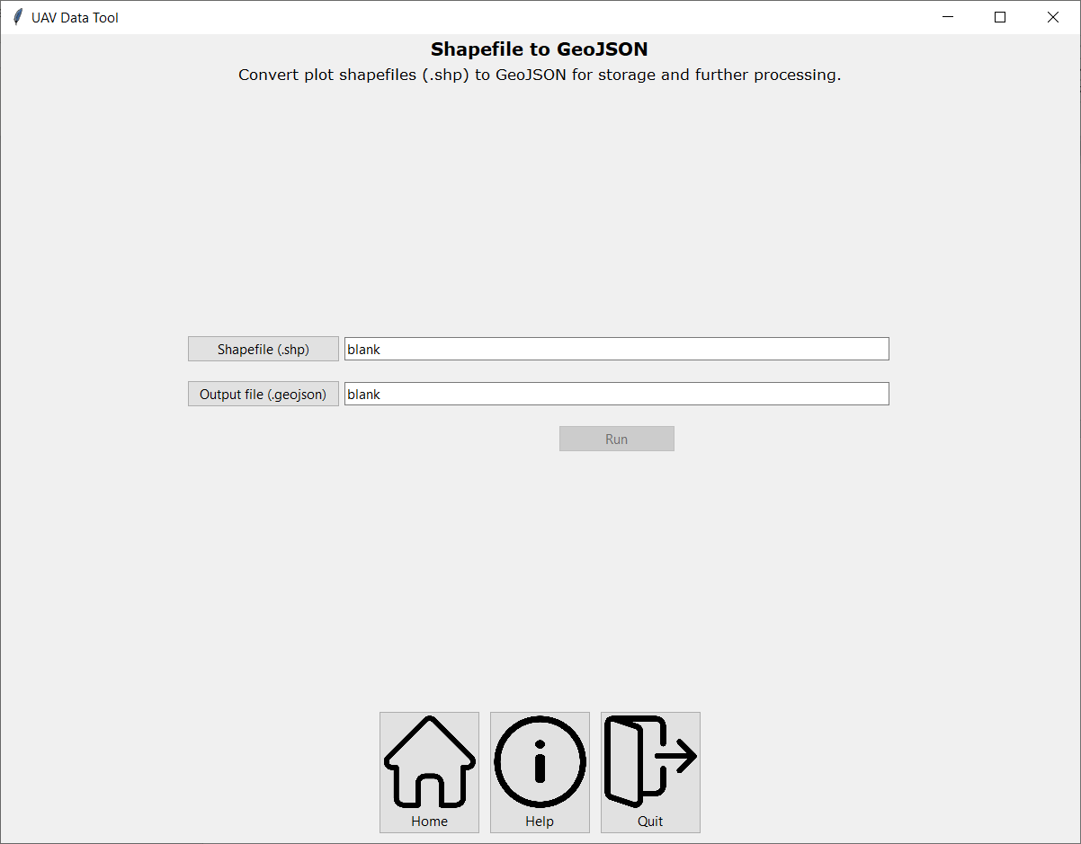

1

3

2

## **5.2 The Workflow:**

1. Shapefile (.shp) – Select input shapefile to be converted to GeoJSON format.
2. Output file (.geojson) – Select output folder and filename.
3. Run – Double check inputs/outputs then begin processing selected shapefile.

## **Errors**

* Double check the input shapefiles are in an appropriate Coordinate Reference System. The tool will output in WGS84.

# **Chapter 6. Data Extractor Tool**

This tool is designed to extract key statistical results from all bands in the provided orthomosaic file. The tool uses user made shapefiles that identify the Areas of Interest from which key statistics are extracted and saved to a spreadsheet.

Key features:

* Designed to work with a variety of different spatial datasets.
* Will work with flight lines from Headwall HyperSpec system and will process multiple flight lines in one go – *so a single experiment from several flight lines*.
* Extract all pixel values from plots to a CSV file.
* Select different statistic samplings, depending on requirement.

## **6.1 The Tool**

To access the tool, from the homepage select the Data Extraction Tool button. This will open the tool and present the page below.

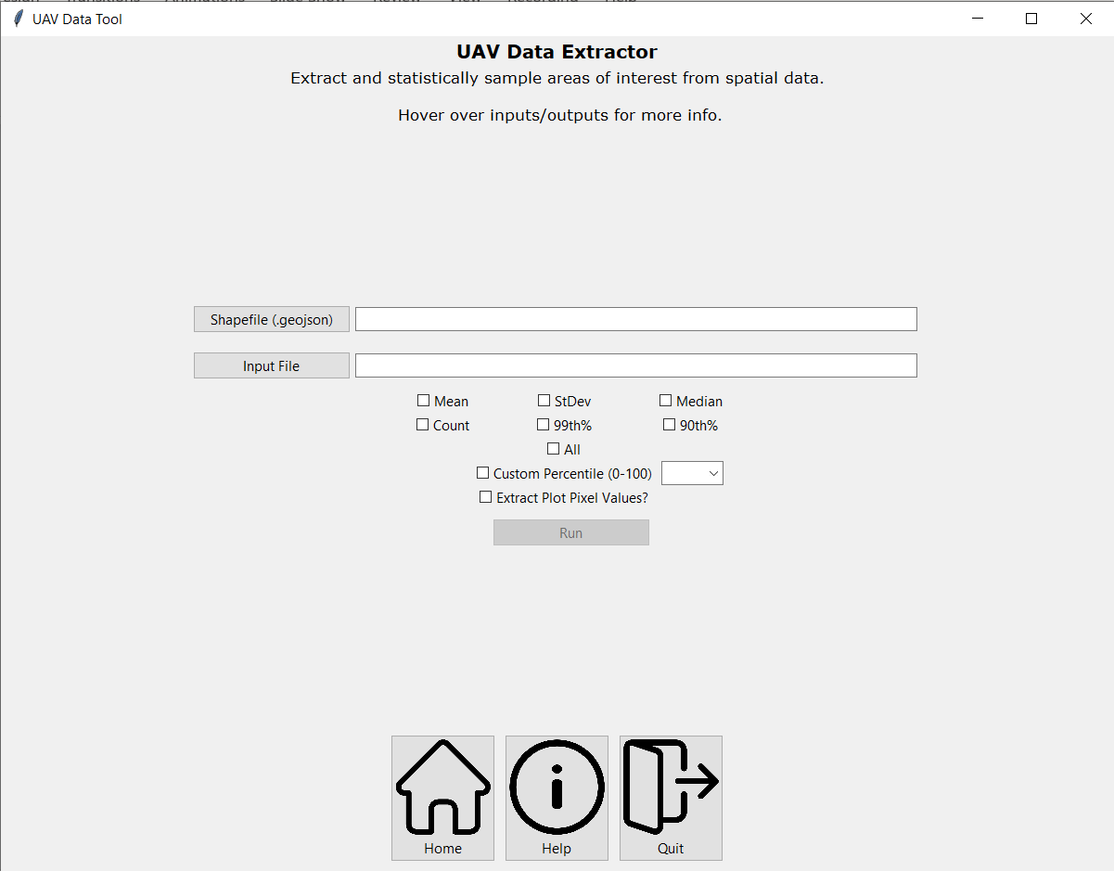

1

2

3

4

5

6

The tool takes a number of inputs which are explained below:

1. **Shapefile** – the GeoJSON file containing the AOI shapefiles.
2. **Input File** – the georeferenced orthomosaic from which statistical information will be extracted.
3. **Statistics** – Select which statistics to be derived during processing. Select All to derive all.
4. **Custom percentile** – Select to derive custom percentile (0-100) during processing.
5. **Extract Plot Pixel Values?** – Select to extract all pixel values from each plot in to separate CSV files. Will request a folder path directory where to save the CSV files.
6. **Out File** – location and file name where the output is to be saved in CSV format.

## **6.2 The Workflow**

To steps below describe the steps taken to process a single dataset:

1. Select the plot shapefile (.geojson)
2. Select data file/s to be extracted.
3. Select output file path.
4. Select statistics to be sampled from data.
5. Select if pixel values are to be extracted, and provide a folder directory.
6. Ensure the correct shapefile has been selected.
7. Check location and filename of output, edit if required.
8. Once all inputs are selected, press ‘run’ to being processing the image set.
9. ***Monitor progress in CMD window*.**

## **6.3 Errors**

1. Ensure shapefiles and orthomosaic overlap.
2. Check CMD window for error outputs.
3. Thoughts and prayers

# **Notes**